July 17, 2025

Re: Sectional Road Replacement Program Pall Mall Drive, Camel Drive City Project 25-449
Dear Resident:
Sterling Heights City Council has approved the reconstruction of Pall Mall Drive and Camel Drive by Galui Construction Inc. Construction is tentatively set to begin with pavement cutting and limited sidewalk removal, marked by the city during the week of July 21st (weather permitting). If your house is one of the specified locations, the marked sidewalk will be replaced at no additional cost.
Phase 1 of roadway pavement removal will begin after all the marked sidewalk has been replaced. Traffic will be reduced to one lane in the work area during the project. The grass between the street and sidewalk and your private driveway approach are not included in the repair and shouldn’t be disturbed. However, any areas disturbed by the contractor will be restored at the end of the project, including sprinkler repairs.
The project will have 2 phases (see the back side of this letter for more info), and you’ll be given written notice at least 24 hours prior to the start of work in your phase. Please have your vehicles moved outside of the designated work area upon receipt of this notice. If you are adjacent to a replacement location, you won’t be able to access your driveway for the approximately 2-3 weeks it will take to complete that phase. Please do not drive on the fresh concrete until barrels are removed by the City (usually about seven days). This will allow the concrete to become strong enough to tolerate vehicles.
During the project, please place your trash in the approved trash/yard waste bins. On your normal refuse collection day, trash bins will be labeled with your address and picked up by the contractor to be wheeled to a location outside of the work zone where Priority Waste will be able to pick up your trash. The bins will be returned after collection is complete. The same will be done for recycling. Mail service will not be impacted by the road work.
Please be aware that winter de-icing will be extremely limited or eliminated over the first 1-2 years to best preserve the surface of the pavement.
Construction information and progress updates for the project can be found at sterlingheights.gov/conezone, or to receive regular project updates via email or text, visit sterlingheights.gov/notifyme and subscribe to the “Sectional Road Project: Pall Mall Dr. / Camel Dr.” alerts or scan the QR code below.
If you have any questions, please contact the Office of Engineering at (586) 446-2720 or nholly@sterlingheights.gov. This road improvement project was made possible as a direct result of the voter-approved Safe Street Millage that was renewed in November 2019.

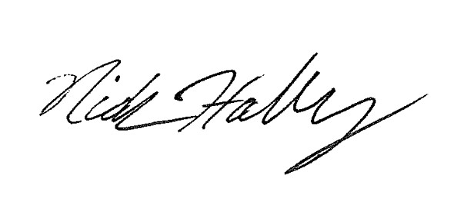
Sincerely,

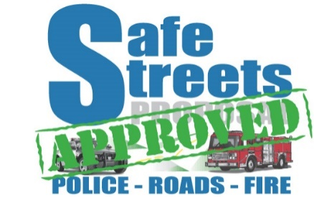
Nick Holly,

Civil Engineer II

cc: Brent Bashaw, City Engineer; Community Relations; Fire Department; Police Department

